Python bootcamp day 22 build pong game

<https://www.udemy.com/course/100-days-of-code/learn/lecture/20414753#overview>

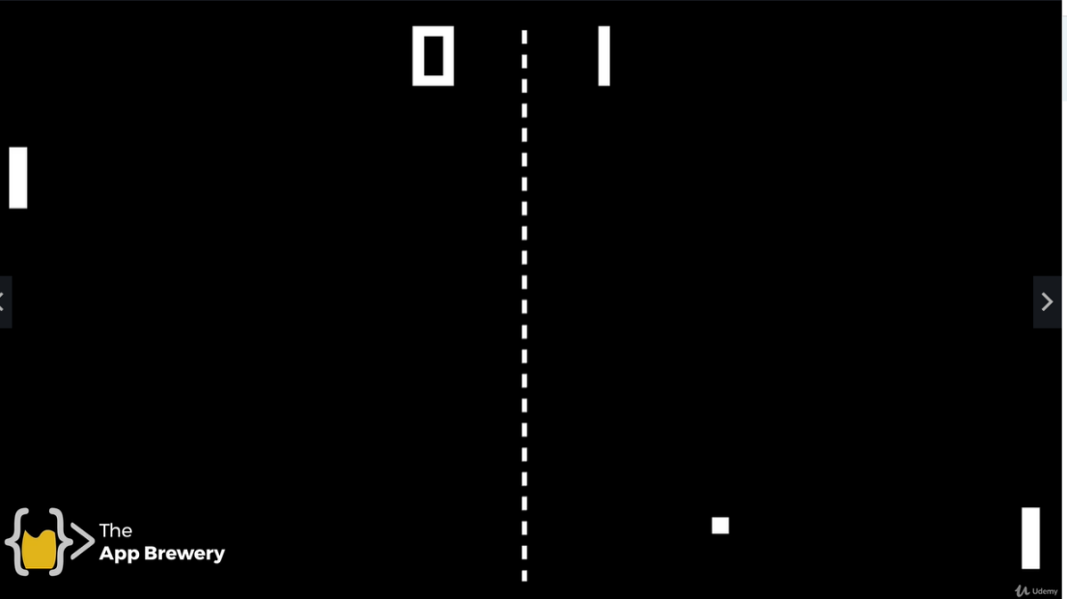

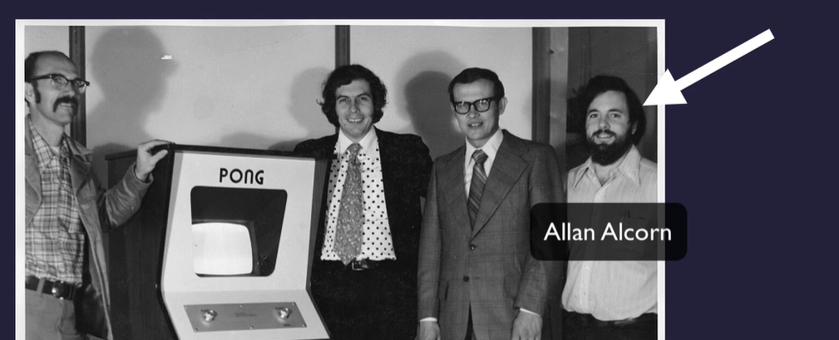

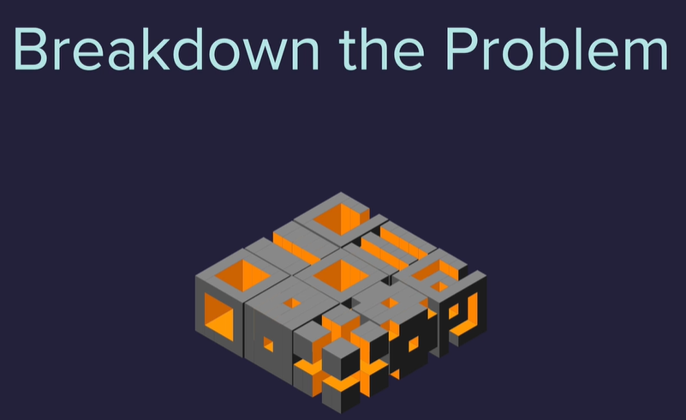

What aspects can go into their own file or class

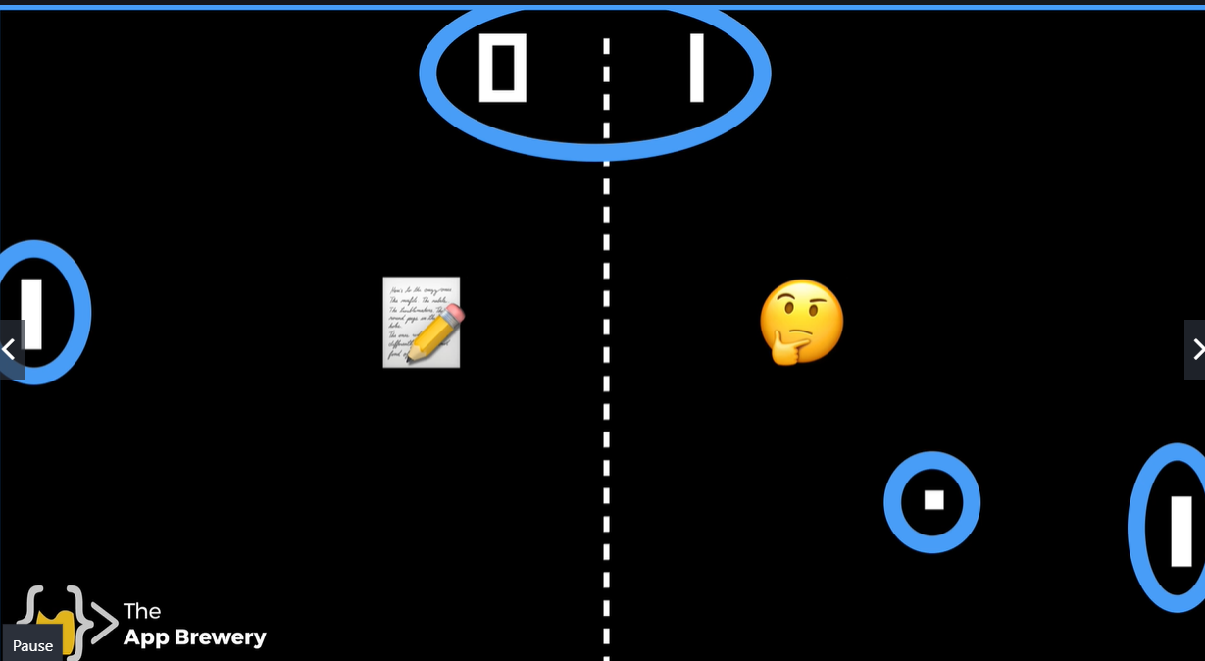

Main, ball , paddle, scoreboard 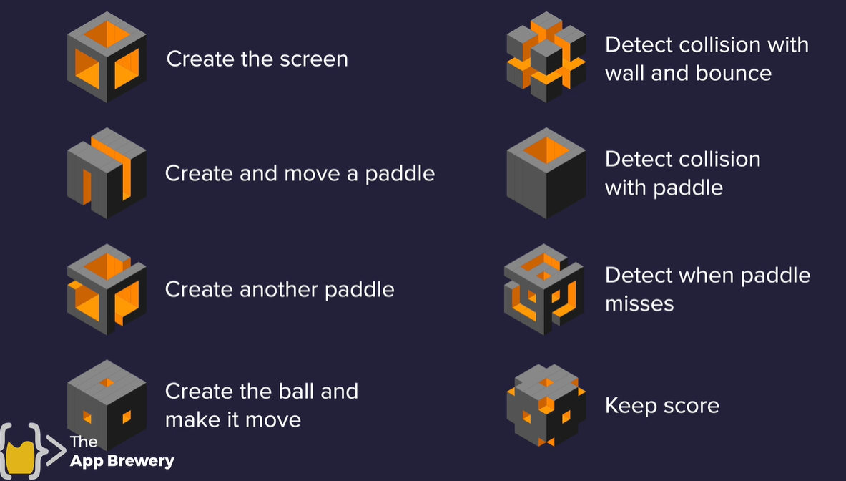

Create screen

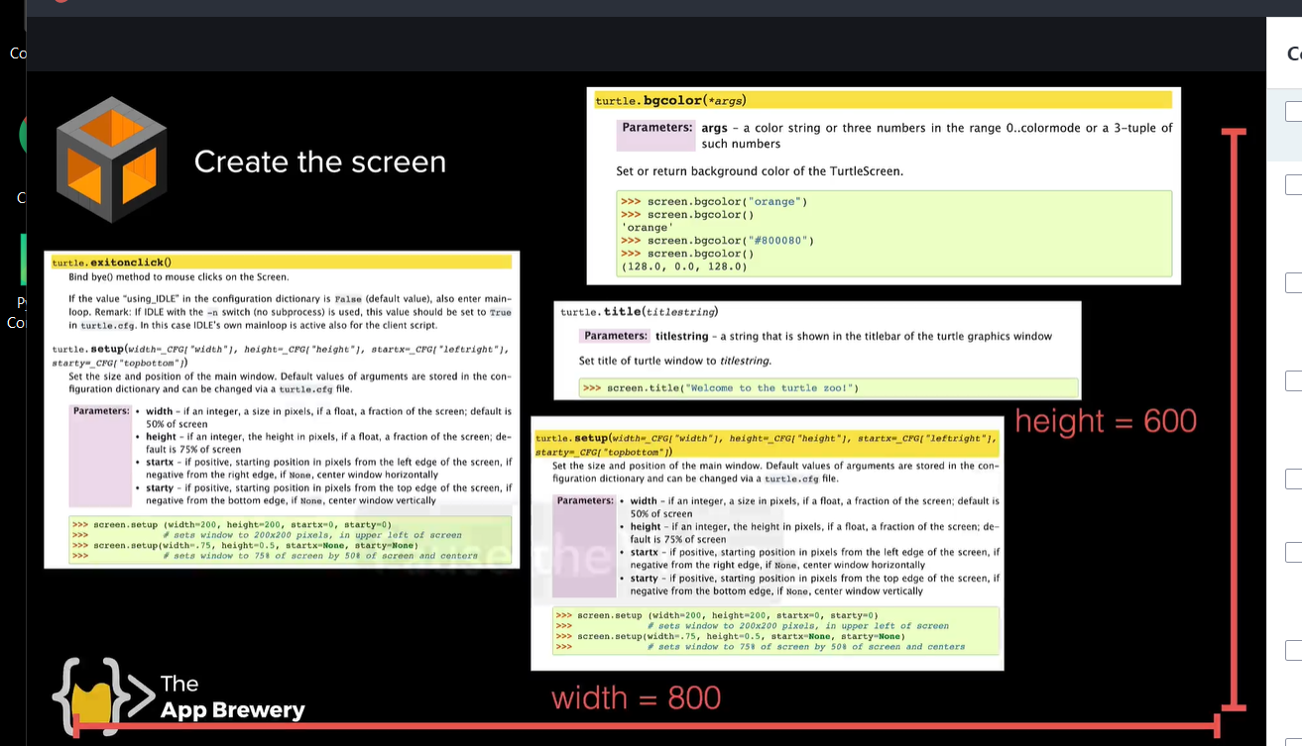

#imports

from turtle import Screen

#

import time

# Create the screen

screen = Screen()

screen.setup(*width*=800, *height*=600)

screen.bgcolor("black")

screen.title("Pong")

screen.tracer(0)

# TODO Create and move paddle

# TODO Create another paddle

# TODO Create the ball and move it

# TODO detect collision with the wall and bounce

# TODO detect collision with paddle

# TODO detect when paddle misses

# TODO keep score

screen.listen()

screen.exitonclick()

Draw right side paddle

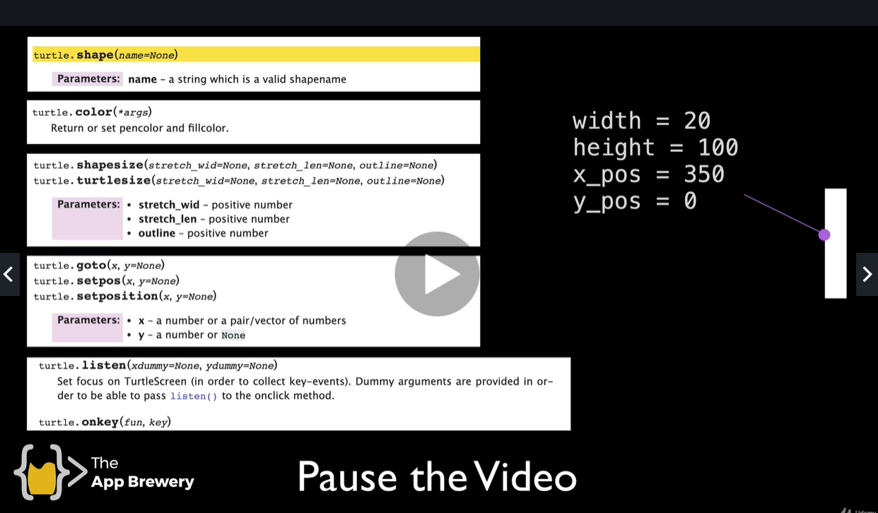

#imports

from turtle import Screen,Turtle

#

import time

# Create the screen

screen = Screen()

screen.setup(*width*=800, *height*=600)

screen.bgcolor("black")

screen.title("Pong")

# turn the screen off to not see the paddle move from center

# to its position on the right at start to game.

# when useing screen.tracer will need to turn it back on in the

# while loop below while game_is_on

screen.tracer(0)

# Create and move  R paddle

paddle = Turtle()

paddle.shape("square")

paddle.color("white")

paddle.shapesize(*stretch_wid*=5, *stretch_len*=1)

paddle.penup()

paddle.goto(350, 0)

*def* go_up():

    #the current y position of the paddle + 20

    new_y = paddle.ycor() + 20

    paddle.goto(paddle.xcor(), new_y)

*def* go_down():

    new_y = paddle.ycor() -20

    paddle.goto(paddle.xcor(), new_y)

screen.listen()

#when passing in a function as a paramater omit the parens

screen.onkey(go_up, "Up")

screen.onkey(go_down, "Down")

game_is_on = True

while game_is_on:

    screen.update()

# TODO Create L paddle

# TODO Create the ball and move it

# TODO detect collision with the wall and bounce

# TODO detect collision with paddle

# TODO detect when paddle misses

# TODO keep score

screen.listen()

screen.exitonclick()

create paddle class and left paddle

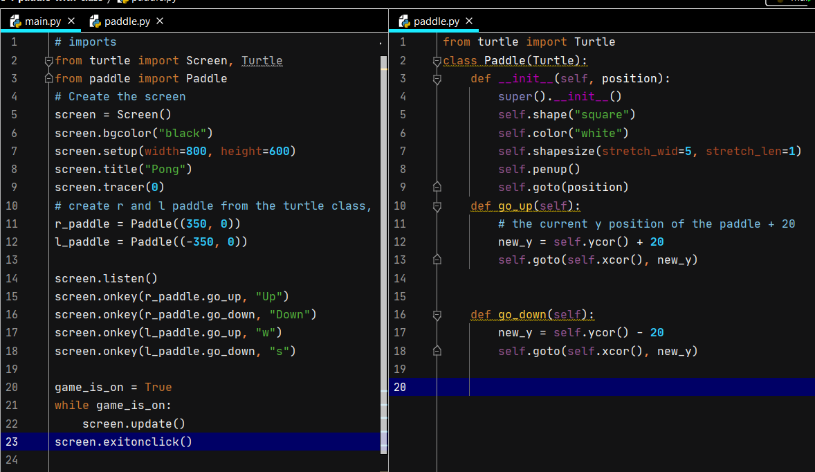

Create ball in middle of the screen and when the screen refreshes ball balls x and y move it to the upper right of the screen

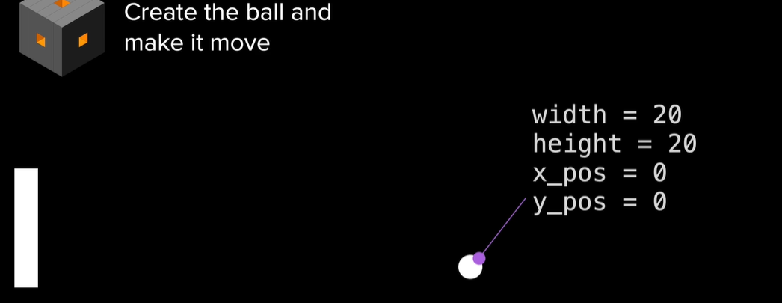

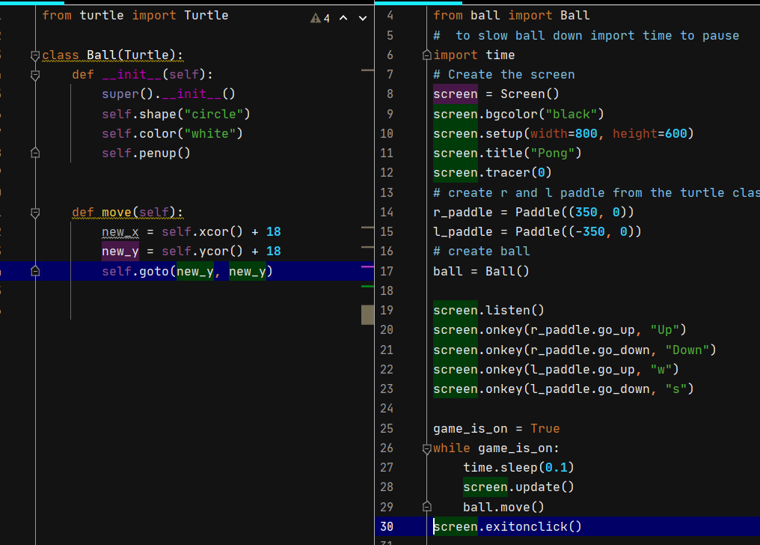

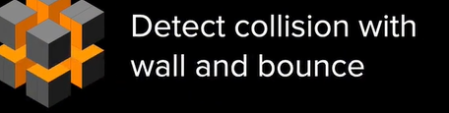

Just top and bottom wall need bounce (collision) needed . What position is that ?

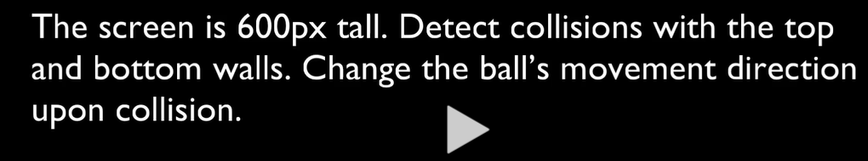

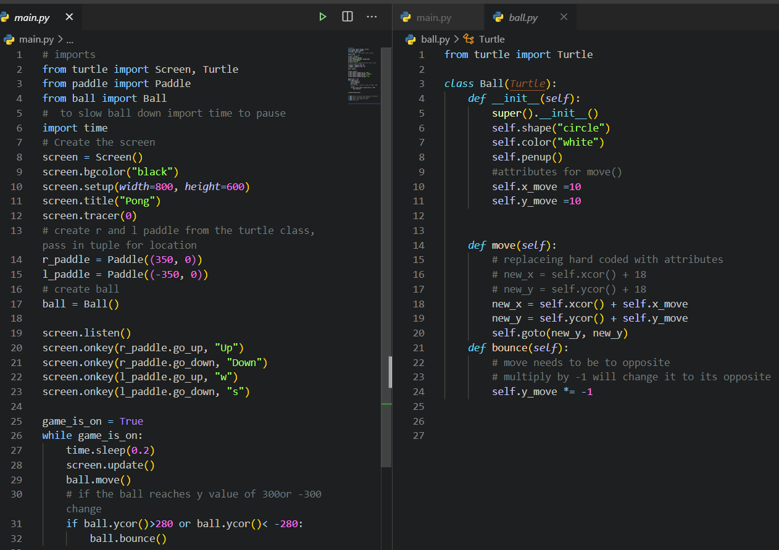

Detect collision with Paddle and make ball bounce off the paddle.

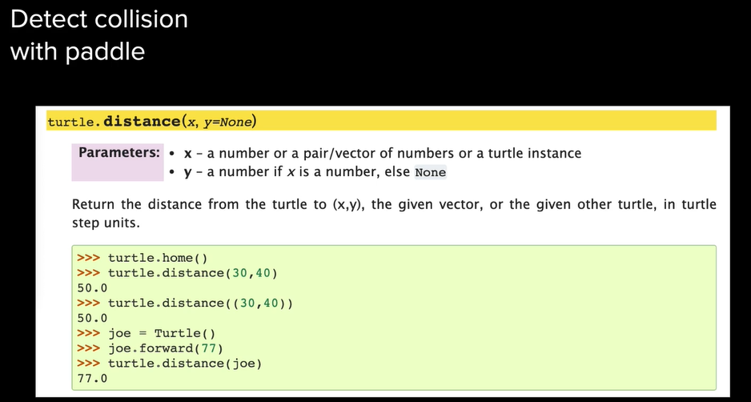

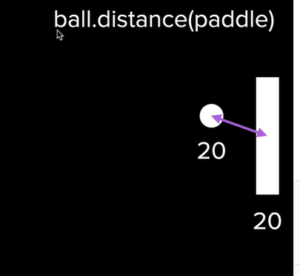distance is from the center 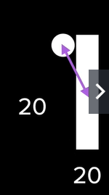

To solve this

